Web-Project (LKGI – Website) –
(Home Page)

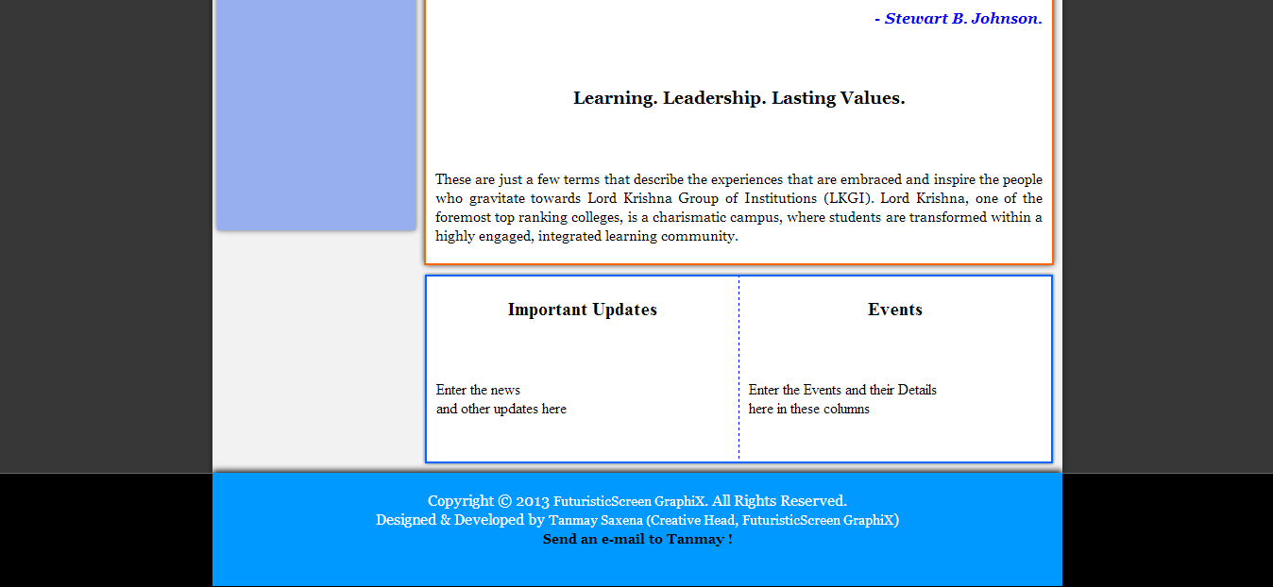
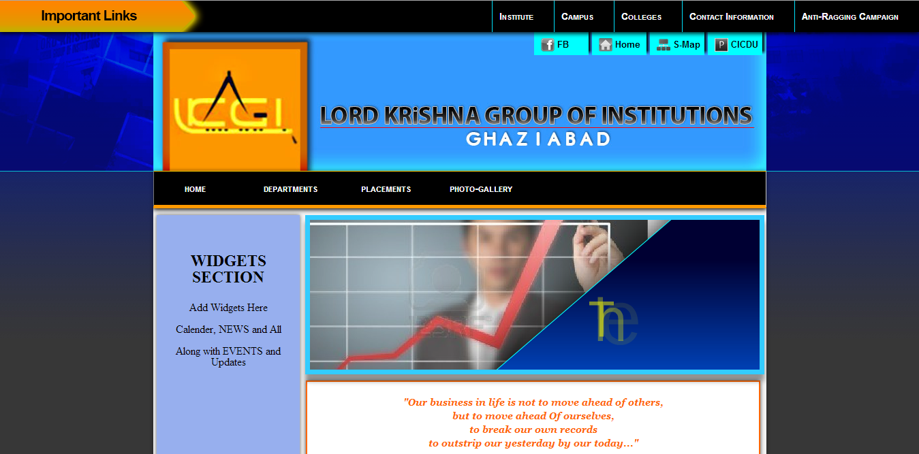
This is the first page for the College Website designed in this Mini-Project Lab and alongside the other pages made as a part of the Web-Project are attached in the Lab-File later on.
Before moving onto the other web-pages, let us understand how to Traverse through the pages using the Navigation Panel that has been provided in the website.

(The Navigation Panel) –

The Navigation Panels on this Web-Project unlike the previosuly established website have been broken down into 3 sections :-

- IMPORTANT LINKS
- Linker-Panel
- Menu-Strip

A - IMPORTANT LINKS
This panel for Navigation packs the links that are the base for Important Information in the site, i.e., sources of information like the About Institute, About Campus, About Colleges, Contact Information and Anti-Ragging Campaign can be reached using the links provided in this section of the Navigation Panel.

B - Linker Panel

This section helps the users to connect to the various connections and the facilities that the college website provides or the college has. The Linker Panel has been modernized with the CSS3 Animations that provides it that better edge over the pre-existing tab sections that were being used earlier.
- Connectivity to College’s FB Page
- Connectivity to the Homepage
- Connectivity to the Sitemap of the Complete Website
- Connectivity to the Placement Desk / CICDU.

C - Menu-Strip

Connects the user to the rest of the pages, that are available online.

- Home
- Departments
  - CSE
  - IT
  - ECE
  - EEE
  - ME
  - Applied Science
- Placements
  - CICDU
- Photo Gallery (Undeveloped at the moment)

Other Important Section Details –

Some of the other sections that have been used in the website for other purposes have been described below.

WIDGETS SECTION –
Placed on the left hand side of the Web-Pages, this section provides the space for the various widgets that the site might be using or would want to use. This section has been casted in the website as the Glass Window that would provide space for the Widgets to be fitted into.

Widgets such as Calender, Announcements, Events and Updates, News, etc. can be placed here in this Widgets Holder.

MAIN BODY SECTION –

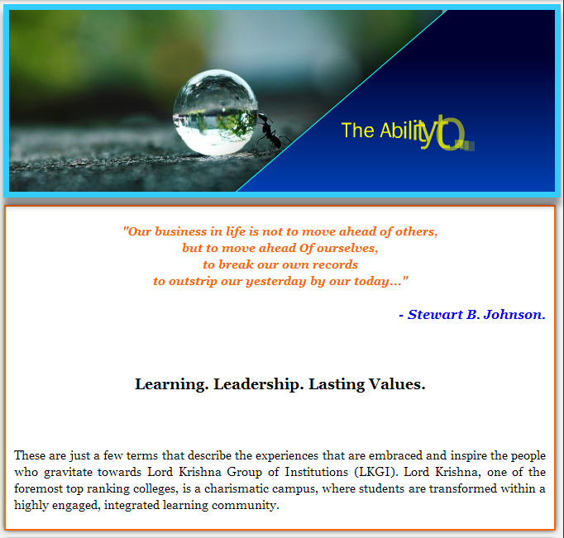
This section holds the Main-Body of the Web-Page and contains all the text and data for that very text page along with the Headings and Data.
Along with that it also contains the FLASH / JPEG Banners that go along with each and every webpage.

Events and Updates SECTION –

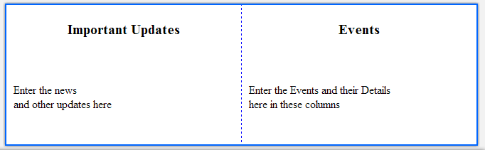
The Events and Updates Section provides the Important Updates and Events to the Clients of the Site.
Special News and Announcements are also covered under this section.

Connect to the Developer SECTION –



Provides the users the direct link to interact with the developers with hyperlinks present both for Facebook Pages connectivity and the e-mailing structure option that has been embedded using Hyperlinks and Javascripts.
This section provides the in-depth knowledge about the copyrights held by the person/company that has developed the webpage.

The overall website presents in front of the users the Documentation Papers format that is better known for its Quality and Presentation and would present to the viewers of the site one side of what Higher Education and Presentation Skills means in the lives of an Engineer. It shows what the college would inculcate in their lives if they choose to join this college.

